**TASK 4 (MAR 04 2025) DINESH KUMAR M,**

**1. What is the purpose of the core module in AEM?**

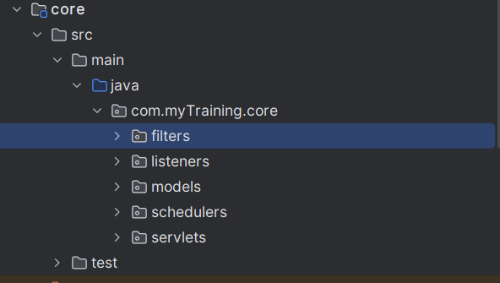

Core modules contains the backend logic for handling the datas, processing them and other services. These are implemented using java code.

Core modules includes like Sling,servles,and OSGI services

Main purpose of core modules are : to handle API endpoints interaction,expose backend data through sling and define services that forms the business logic of the AEM components

**What kind of files and code can be found in the core folder?**

The core folders is present in the path: /core/src/main/java/com/ myTraining /core

Java class files such as models ,services, filters, schedulers ,servlets etc.

XML files that contains configurations and dependencies

Testing files written in java using Junit

**Explain the role of ui.apps in AEM projects.:**

Stores content like components, templates, client libs, and static assets.

It provides the overall structure and presentation layers for AEM.

**How are components structured in the ui.apps folder?**

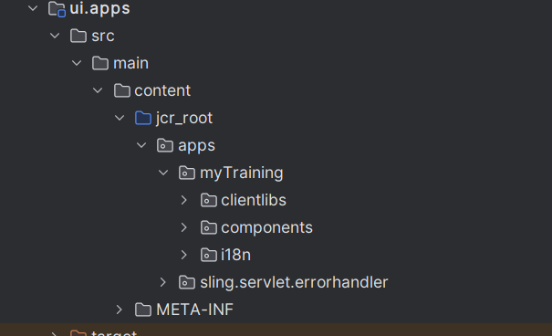

It contains html, xml and client libs files such as css and javascript

**Hello World Component:**

* **Where is the Hello World component located in both core and ui.apps?**

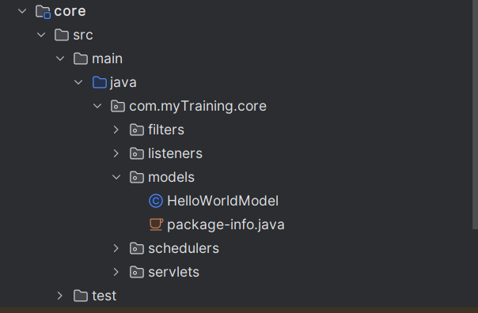

Path : /core/src/main/java/com/myTraining/core/models/HelloWorldModel.java

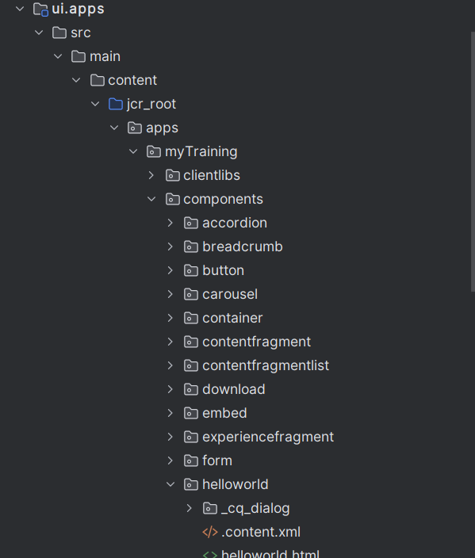

Path: /apps/ myTraining /components/helloworld/

* **Explain the Java class (in core) for the Hello World component.**

It contains annotations for models and sling objects which inject the properties such as variables and methods between the Sling Model and java code

* **How does the HTL script work in ui.apps for Hello World?**

It helps to bind the model and render the properties . In Hello World class we have methods like getmessage that print the message

* **How are properties and dialogs defined for this component?**

Properties are defined in .content.xml files and dialog is also defined using xml files under cqdialog folder . It is used for input purpose like configuring editable fields

**What are the different types of AEM modules (core, ui.apps, ui.content, etc.)?**

Core –Sling Models, OSGi Services etc.

all: Aggregates packages for deployment.

ui.apps –front-end components, templates, clientlibs.

ui.content – Contains site-specific content

ui.tests – Used for testing

dispatcher – Used for caching and configurations for AEM Dispatcher.

**How does Maven build these modules?**

Modules built as OSGi bundles and content packages .

It also make use of pom.xml file to map the dependencies and intstall the necessary packages

**Explain the build lifecycle of Maven in the context of AEM.**

Compile the java code run the testing code and test the javacode then installation ,build and deploy

In brief: compile -> run -> test -> install -> build -> deploy

**How are dependencies managed in pom.xml?**

The required dependencies are mentioned in the pom.xml file

From which the maven automatically installs and update the dependencies(JAR files) based on the given metadatas

**Why is Maven used instead of other build tools?**

It make the process of installing the dependencies easier and standardised. It handles the bundles and packaging of OSGI Bundles

Command : mvn clean install or mvn clean install -PautoInstallPackage -Dmaven.test.skip=true

**What advantages does Maven offer for AEM development?**

Auto-deploys content packages to AEM and autoInstallBundle

**How does Maven help in managing dependencies and plugins in AEM projects?**

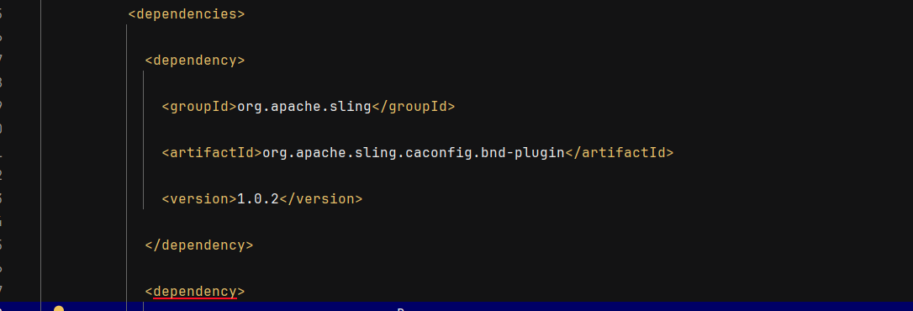

It simplifies the dependency management by populating them under one file ie. pom.xml

**What does mvn clean install do in an AEM project?**

It deleted the previously installed dependences and create a fresh new build

It fetched the jar files mentioned in the pox.xml and install them in the maven dependencies

Command : mvn clean install or mvn clean install -PautoInstallPackage -Dmaven.test.skip=true

**How to deploy packages directly to AEM using Maven commands?**

mvn -PautoInstallPackage install

**Explain the purpose of different Maven profiles in AEM (autoInstallPackage, autoInstallBundle).:**  
autoInstallPackage: Auto-deploy content packages to AEM.

autoInstallBundle: To deploy OSGI bundles.

**What is the purpose of dumplibs in AEM?**

It is used to debug client libraries

It helps to view loaded client libraries and their paths or file strcture

**How can you view client libraries using dumplibs?**

Open /libs/granite/ui/content/dumplibs.html.

Enter the category name (e.g., project.base).

View the associated JS/CSS files.

**Explain how client libraries are structured in AEM.**

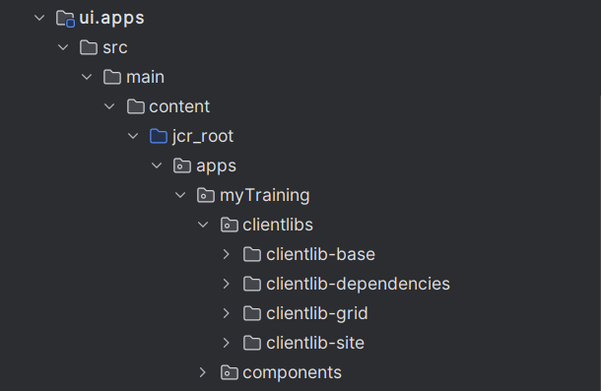

Client Libraries in AEM are used to manage front-end assets like CSS, js, images, and fonts. They helps to optimize the performance by minimizing, versioning.